**Industrial Revolution- The Impact upon the artisans**

**The Industrial Revolution was an economic revolution that started in Britain around 1750. The Industrial Revolution marked a major turning point in history. This mainly included new**[**chemical manufacturing**](https://en.wikipedia.org/wiki/Chemical_manufacturing)**and**[**iron production**](https://en.wikipedia.org/wiki/Puddling_(metallurgy))**processes, the increasing use of**[**steam power**](https://en.wikipedia.org/wiki/Steam_power)**and**[**water power**](https://en.wikipedia.org/wiki/Water_power)**, the development of**[**machine tools**](https://en.wikipedia.org/wiki/Machine_tool)**, and the rise of the**[**mechanized**](https://en.wikipedia.org/wiki/Mechanization)[**factory system**](https://en.wikipedia.org/wiki/Factory_system)**. Output greatly increased, and a result was an unprecedented rise in population and the rate of population growth. As the demand for more products grew, the old domestic system of artisans working at home with simple tools was replaced by the factory system, where the large machines now produced faster and more abundant in supply.**

**Britain started producing factorized goods and textiles that were cheaper than Indian goods. They were better in quantity and quality. Indian handicrafts partially died as they could not contend with the cheaper products from Britain that were flourishing in the Indian markets. Weavers were made to register with the company, after that they could not work for others or themselves. When raw cotton was exported from India, the fabric material was imported.**

**The Industrial Revolution was very handy for humans but it has brought many problems with it. Such as child labor, health issues for factory workers, greenhouse gases, and many more. According to my perspective on the Industrial Revolution, it was a slow poison that killed the elixir of the earth. Well, I was referring to the global warming that contaminated the purity of our home.**

**Mahatma Gandhi spinning the cotton thread on the wheel – Traditional method** 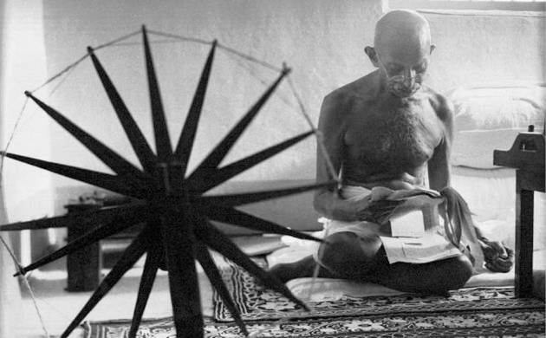

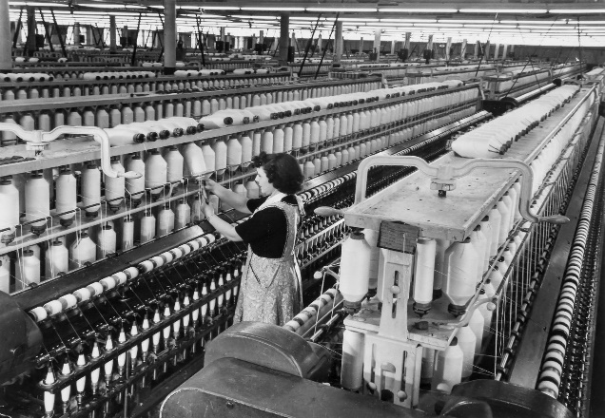

**Spinning the cotton in the factory in late 19th century- Mechanized way.**